 |  |  |  | Full Paper (type of the article) Tahoma 13p
Dedication (optional) Tahoma 12p italic
Title of the paper (Tahoma 16p, single interline)
FirstNameofAuthor1 LastNameofAuthor1⁽¹⁾, FirstNameofAuthor2 LastNameofAuthor2⁽²⁾
 | ⁽¹⁾ Affiliation of Author1, ⁽²⁾ Affiliation of Author2, Tahoma 11p, single interline
 | Correspondence to: email@email.com
 | Abstract: |  | Tahoma 11p, single interline, (Essential information of the work briefly in maximum 150 words. Technical details and scientific background should not be specified at this point)
 | Keywords: |  | Tahoma 11p, single interline, Keyword2, Keyword3
 | Received: |  | xxxx.xx.xx
 | Accepted: |  | xxxx.xx.xx
 | Published: |  | xxxx.xx.xx
 |  |  | DOI: xxxxxxxxxxxxx
Introduction (Tahoma 12p, bold, 1,5 interline)
(Tahoma 11p, 1,5 interline). In the introduction part, authors must carefully analyse the literature and provide the reasons as to do this research. The current state of the research field should be reviewed carefully and key publications cited. Authors must also clearly state the novelty of the paper in this part and specify the differences between this work and previously published works. Key goals of the work should be precisely specified. This part should be prepared reasonably for the broad range of readers.

Results and discussion (Tahoma 12p, bold, 1,5 interline)
Subparagraph title (optionally; Tahoma 12p. 1,5 interline, underline
Text of the paragraph: (Tahoma 11p, 1,5 interline). In the case of experimental works; or Discussion in the case of review works.
Table No. Title of the caption: Tahoma 10p, single interline, 12p before the caption, 6p after the caption.
Tahoma 11p, | Single interline | Centered
Aaa | 1 | 2 | 3434 | Xxx
Bbb | 45 | 45 | 45 | Vvv
Ccc | 12 | 1212 | 2 | Fff

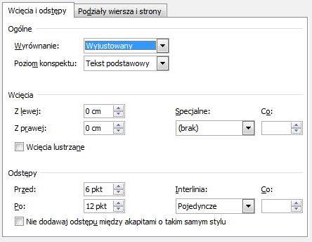
Fig. No. Title of the caption: Tahoma 10p, single interline, 6p before the caption, 12p after the caption.

Material and methods (Tahoma 12p, bold, 1,5 interline)
(Tahoma 11p, 1,5 interline). Commercial sources and/or methods of obtaining all materials for research should be precisely specified. The research methodology should be described in such a way as to ensure full reproducibility of the experiments.

Conclusions (Tahoma 12p, bold, 1,5 interline)
(Tahoma 11p, 1,5 interline). The short summary of the results obtained. The citation of extended works within this sections is forbidden. Technical details should not be specified at this point.

Acknowledgements
(If needed / necessary)

References (Tahoma 12p, bold, 1,5 interline)
References such as www links, commercial folders, non-reviewed papers or books are not allowed. References format should be compatible with ACS style. Examples of types of reference formats (please use format presented below, including order of the data, font size, spaces and indents) for scientific papers [1], books [2], chapter from books [3], patents [4], law acts [5]:
[1] Kovalsky, A.; Smith, J.; Experimental backgrounds for Mars exploration. J. General Sci. 2055, 12, 1234-1256. DOI: 0.000.00000
[2] Smith, J., The title of book. 2000, Publisher. DOI: 0.000.00000
[3] Kovalsky, A.; The title of a chapter in a book, in.: Book Title, (Ed.: Smith J.) 2000, 12-56, Publisher. DOI: 0.000.00000
[4] Kovalsky, A.; Smith, K.; Title of the patent. 2000, Number of the patent.
[5] Title of the law act, number of the law act, 2000 (Country).

Copyright: © 2022 by the authors. Submitted for possible open access publication under the terms and conditions of the Creative Commons Attribution (CC BY) license (https://creativecommons.org/licenses/by/4.0/).

